Project Report

Project Overview

A web application that tells a city’s weather in 3 ways: Minute, hourly and daily. It will also include a media section that shows weather related news and a map displaying the city and its surrounding weather information that is color coded for air temperature.

SDLC

Model: Prototyping

We chose to use the prototyping model because our research deemed it very beginner friendly. We prefer having a clear representation of our project before starting the development so that we can discuss any features we may want to add/remove prior.

Technology Stack

Client’s Side

APIs

1. One Call: retrieves minute, hourly, and daily weather forecasts. Also included are national weather alerts and historical data from up to 5 days prior.

* As Max, I want to play outdoor basketball so we don’t have to reserve an indoor court.
* As Julia, I want to invite my friends so we can enjoy brunch in our backyard.

1. Weather Maps: allows integration of weather maps on our website that features precipitation, clouds, pressure, temperature, wind, and more.
2. Statistical Weather Data: Provides statistical data on main weather parameters for any day and month of the year based on historical weather data. The data is updated every hour.
3. News: Displays recent news that go as far back as 7 days. Searching of the news can be done through keywords.

* As kevin, I want to know the most interesting news in the town, so I have something to say at the dinner table.
* As Fred, I want to know more about the city, so I can write more in my travel diary.

WBS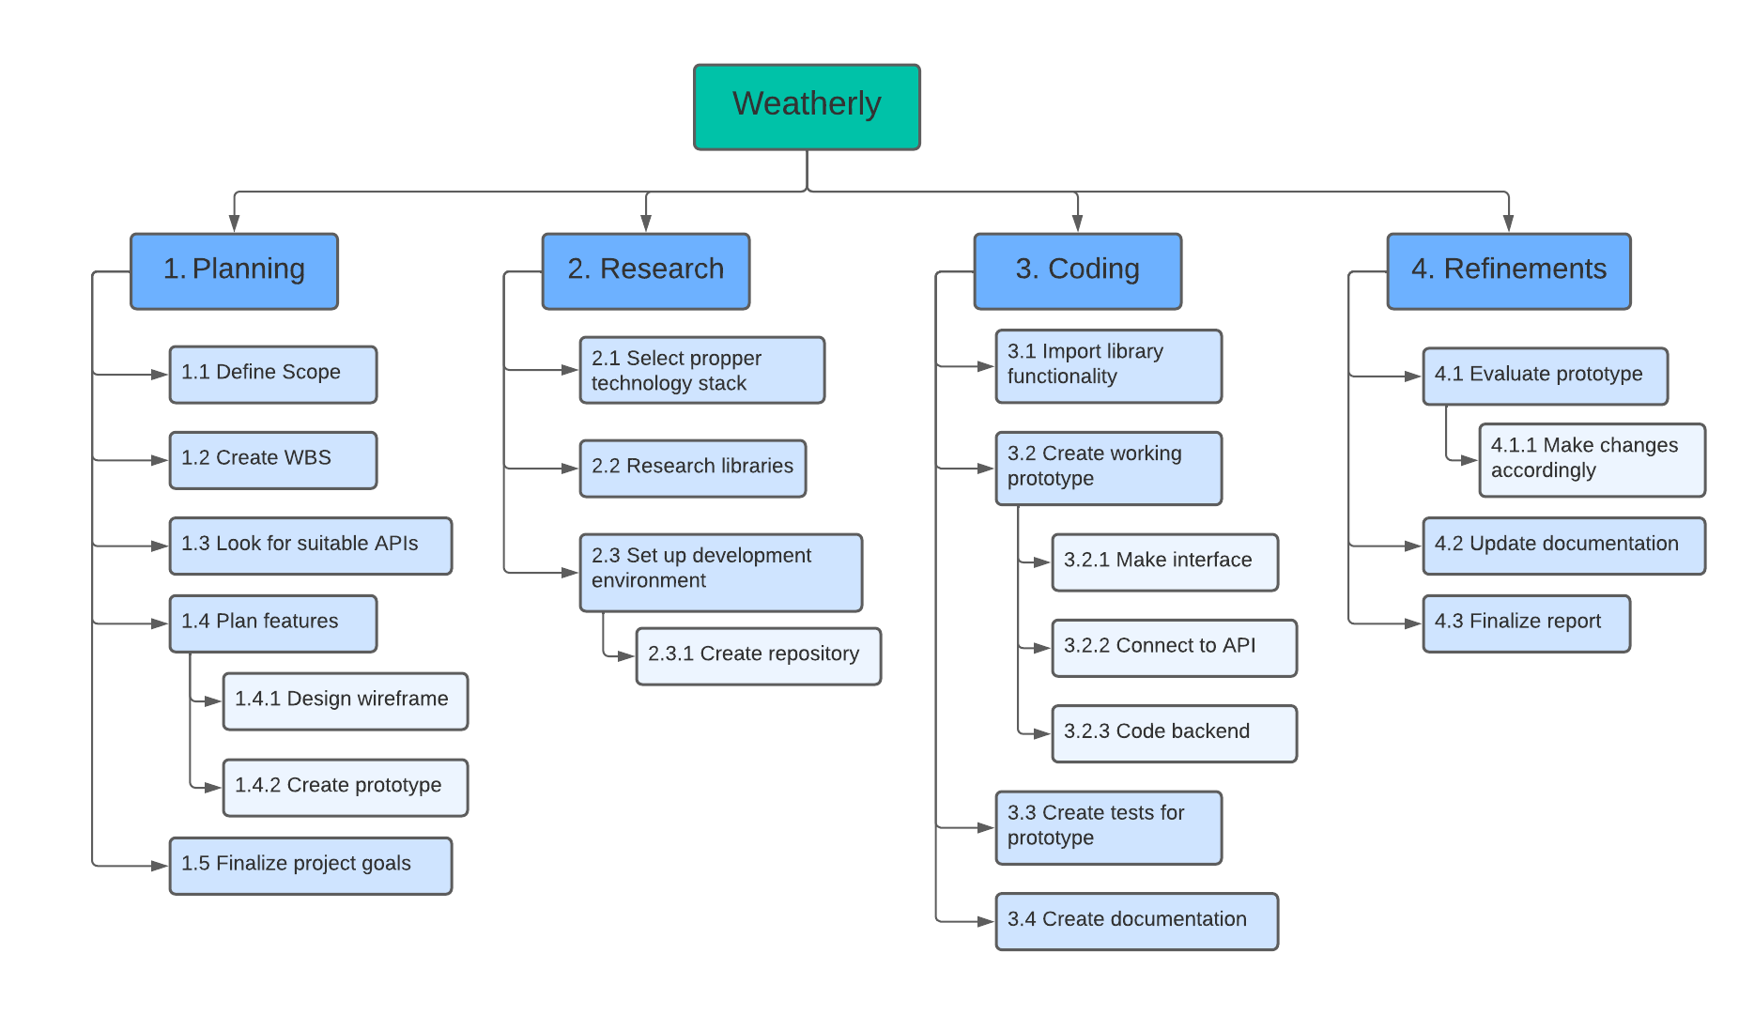

Schedule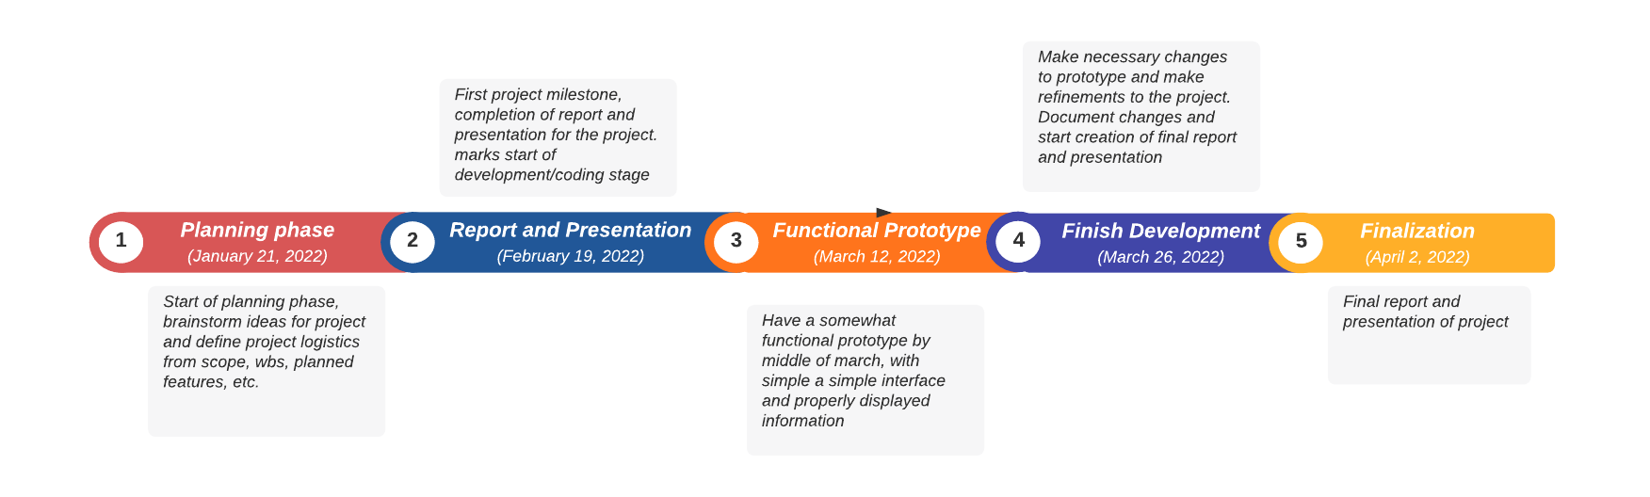

Wireframe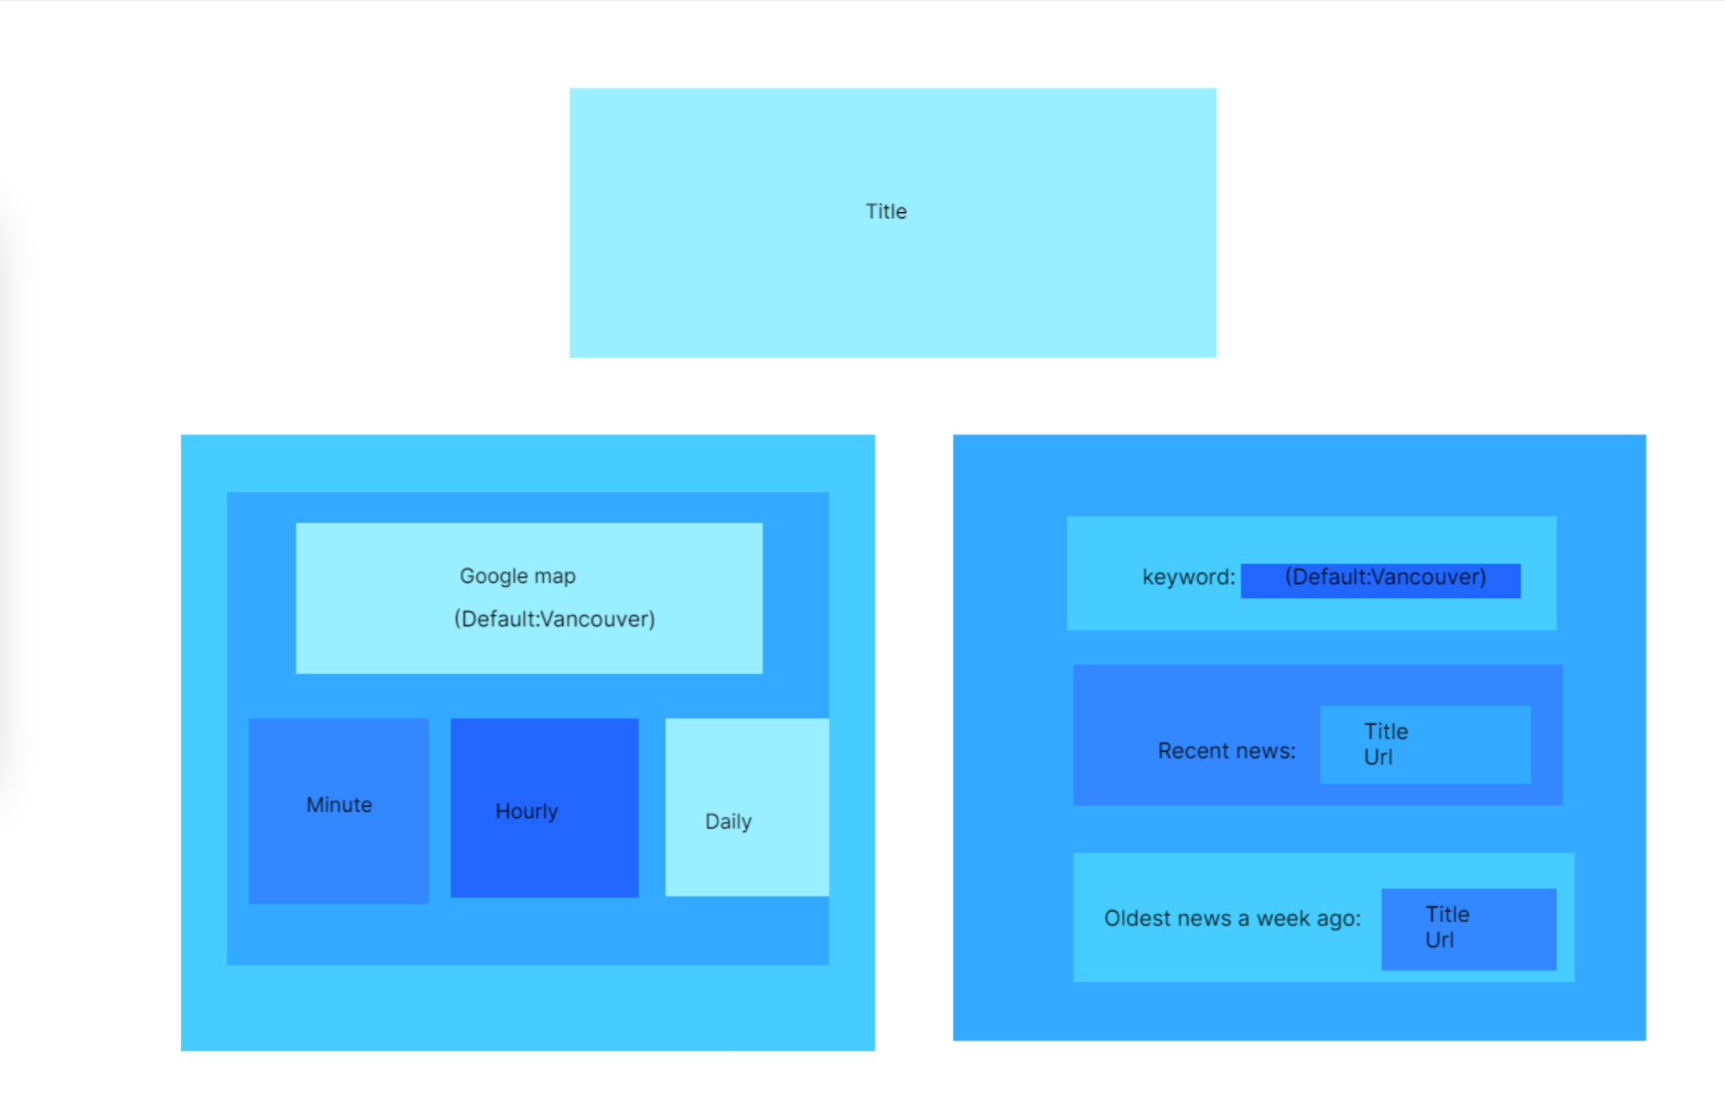

Prototype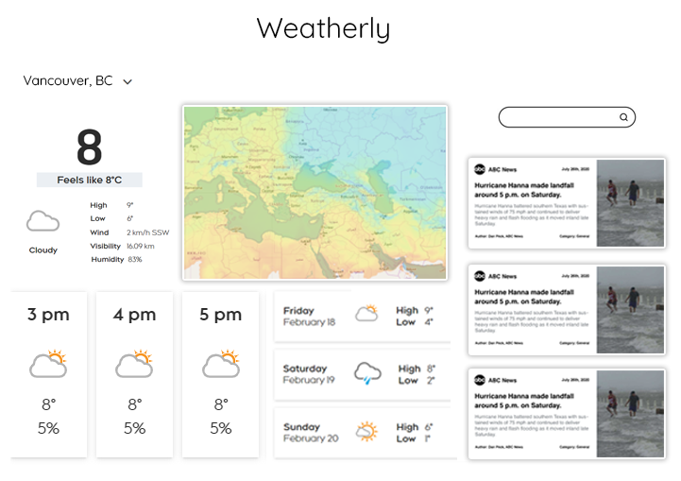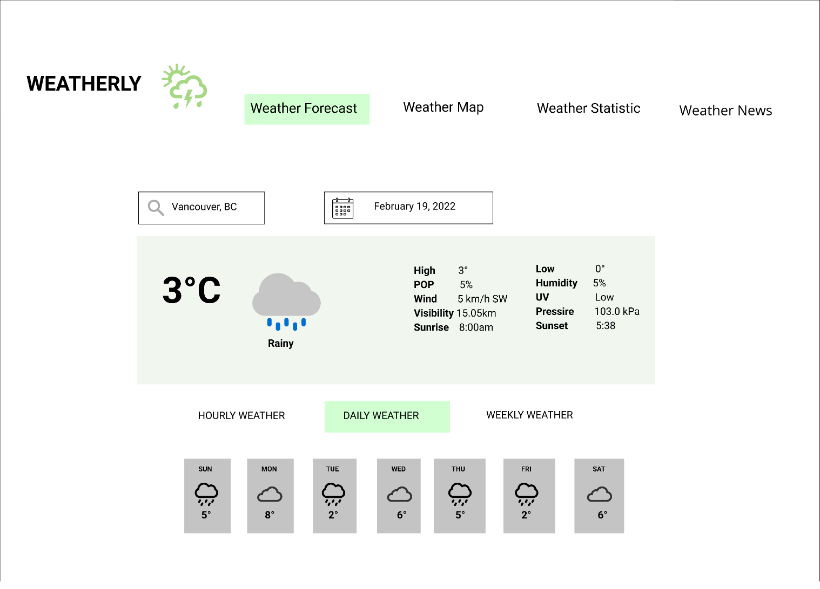

Data Flow Diagrams

* Low-level diagram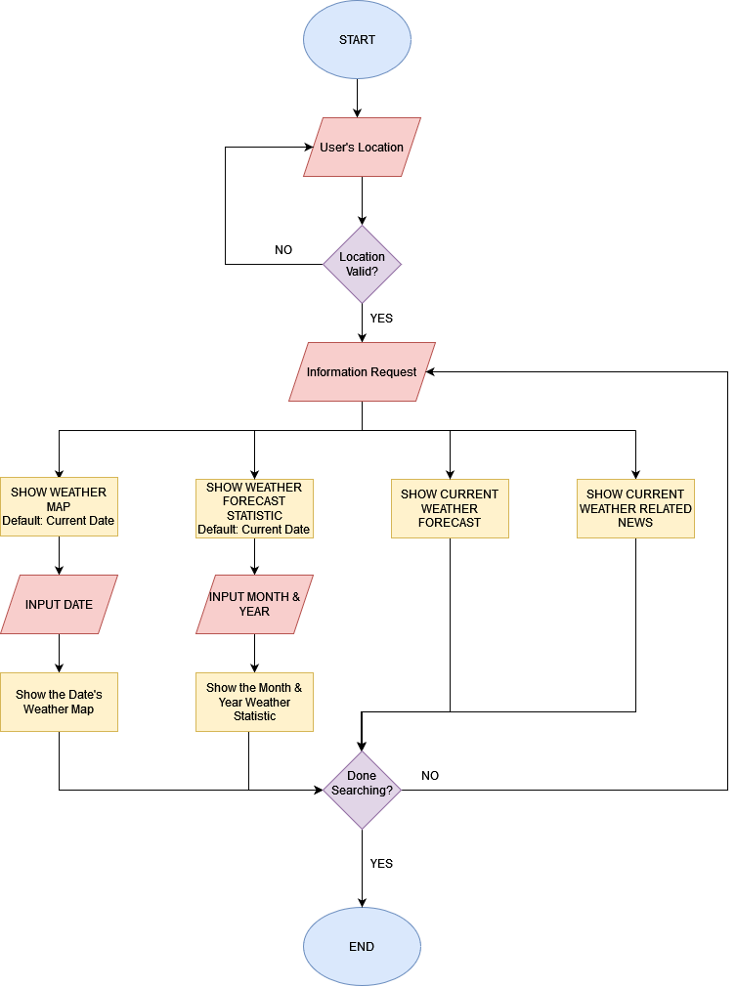
* Low-level diagram